20/10/2021

EU staffers take stock after 18 months of fund to combat Covid-19
The EU Staff Covid-19 Solidarity Response Fund, managed by the King Baudouin Foundation, has launched a review of its priorities as Europe seeks to move beyond the pandemic and to promote environmental improvements as it rebuilds. A conference on 1 October involving donors and experts was also the occasion to look back with pride on 18 months of fund-raising and to share grantees’ stories with those who have contributed.
The Fund, set up as Covid-19 struck Europe in spring 2020, has so far raised over 800,000 euros to help some of those hardest hit by the illness and the economic disruption it caused. Its founders wanted to show that the European Union’s public servants were not distant and aloof but deeply engaged at a personal level with improving the lives of their fellow EU citizens.

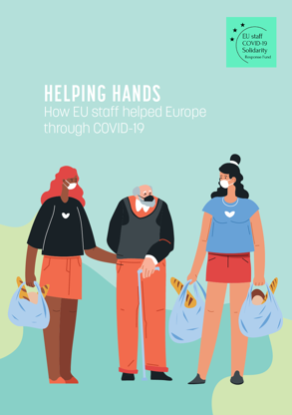

Recipients of their generosity underlined the importance of the speed with which, helped by the King Baudouin Foundation, the Fund was able to identify those in need and get cash to them.

“We needed to react quickly,” said Tereza Koutská of hROM, which offered classes for disadvantaged Roma children during school lockdowns in Czechia. “This money has given
children an opportunity to change their lives.”

“The solidarity shown by the EU staff sends a very powerful message,” said Iva Petrova of BCause, which saw a surge in women coming to its shelters across Bulgaria as incidents of domestic violence surged during the early months of the pandemic. “It was an opportunity for the staff themselves to make a valuable contribution, often in their home countries.”
To download a copy of the EU Staff Fund’s newsletter marking its first 18 months, visit ….
About the King Baudouin Foundation
The King Baudouin Foundation's mission is to contribute to a better society in Belgium, in Europe and in the world. It is an actor for change and innovation, serving the public interest and increasing social cohesion. It seeks to maximise its impact by improving skills in organisations and for individuals. It also stimulates effective philanthropy by individuals and corporations. The King Baudouin Foundation was set up in 1976, on the 25th anniversary of King Baudouin's reign.

