Presented pieces and captions images BRAFA 2023
The images can be downloaded here in high resolution
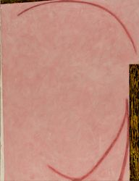 | Hugo Duchateau, Toudekken I-II-III-IV, 1985-1990. Acrylic on canvas, 130 x 180 cm.  Coll. King Baudouin Foundation, Private Art Support Foundation Fund, on temporary loan at Actief Interim, Lummen.  Photo: Pasfoundation
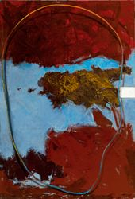 | Hugo Duchateau, Painting with pink spot and hair, 1985. Acrylic on canvas, 120 x 175 cm.  Coll. King Baudouin Foundation, Private Art Support Foundation Fund, on temporary loan at QPS Accountants, Genk.  Photo: Pasfoundation
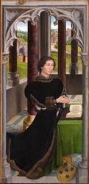 | Hans Memling, Portrait of Francisco de Rojas, 1460-1470. Oil on panel, 105,5 x 50,5 cm.  Donated by The American philanthropist William J. Middendorf, via the King Baudouin Foundation US, to the Musea Brugge (Memling museum / St. John's Hospital), Bruges.
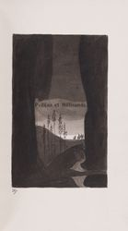 | Illustrations by Léon Spilliaert (1902-1903) in Maurice Maeterlinck, Théâtre, 1901-1902. Illustrations executed in East Indian ink, brush, pen, colored pencil and watercolor.  Coll. King Baudouin Foundation, Eliane Vercaempt Fund, entrusted to the Royal Museum of Fine Arts of Belgium, Brussels.  Photo: Olivier Guyaux Atelier de l’Imagier
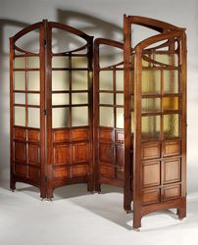 | Paul Hankar, Two folding screens, 1897. Mahogany, colored glass and brass castors, 200 x 180 cm.  Coll. King Baudouin Foundation, Heritage Fund entrusted to the Design Museum, Ghent.  Photo: Philippe de Formanoir
George Morren and Joseph Cossemans, Mantle hook and six ladies buttons, 1894-1899. Cast and chased silver, garnet, 48 x 118 mm (mantle hook), diameter 28 mm (ladies buttons).
Coll. King Baudouin Foundation, Christian Bauwens Fund, entrusted to the Museum of Art and History, Brussels.
Photo: Stephane Briolant
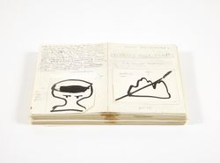 | Pierre Alechinsky, maquette for his book ‘Extraits pour traits’, 1989. Ink.  Coll. King Baudouin Foundation, Marie-Jeanne Dauchy Fund, entrusted to the Wittockiana, Brussels.
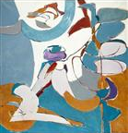 | Louis Van Lint, Le jardin (the garden), 1971. Oil on canvas, 192 x 184 cm (unframed).  Coll. King Baudouin Foundation, Thomas Neirynck Fund, entrusted to the Artothèque in Mons.  Photo: Philippe de Formanoir
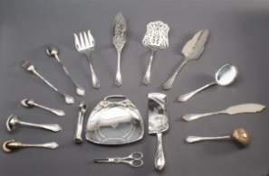  Photo only available in low resolution | Wolfers Frères, serving cutlery Art Nouveau style '207-Modern' with monogram of Victor Horta, ca. 1902. Silver.  Coll. King Baudouin Foundation, Braet-Buys-Bartholemus Fund, entrusted to the Museum Art & History, Brussels.
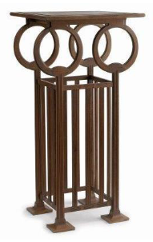  Photo only available in low resolution | Léon Sneyers, Stand for the jug and basin " Aurore ! " by Philippe Wolfers, 1902. Oak, 133 x 65 x 65 cm.  Coll. King Baudouin Foundation, Heritage Fund, entrusted to the Museum of Art & History, Brussels.
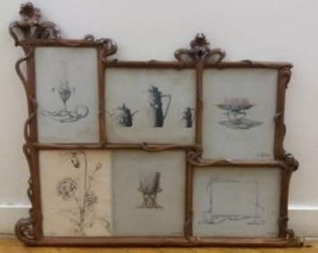  Photo only available in low resolution | Philippe Wolfers, frame with iris motif, c. 1897. Walnut, 88 x 112 cm; and original drawings, c. 1898-1903. Pencil, ink, watercolor, gouache on paper.  Coll. King Baudouin Foundation, Braet-Buys-Bartholemus Fund, entrusted to the Museum of Art and History, Brussels.
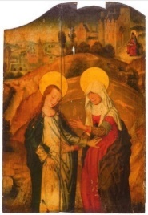 | Master of the View of St. Gudula, Visitation, c. 1490-1500. Oil on oak panel.  Coll. King Baudouin Foundation, Léon Courtin-Marcelle Bouche Fund, entrusted to the Royal Museum of Fine Arts of Belgium, Brussels.  Photo: Köller
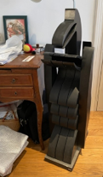  Photo only available in low resolution | Serge Vandercam, Oizal, 1975. Wood, black patinated, 112 cm high (including small base).  Coll. King Baudouin Foundation, Donation from Michel and Fiammetta Wittock in 2018 to the King Baudouin Foundation.

